**University of Michigan – Dearborn**

**CIS 150 – Computer Science 1**

**Lab# 8**

Quan Le

[lmmquan@umich.edu](mailto:lmmquan@umich.edu)

March 8, 2024

**Table Content**

Contents

Question 1 3

Test Cases 3

Source Code 4

Screenshots 4

Question 2 5

Test Cases 5

Source Code 5

Screenshot 5

# Question 1

## Test Cases

|  |  |  |  |  |  |
| --- | --- | --- | --- | --- | --- |
| Test # | Valid / Invalid Data | Description of test | Input Value | Actual Output | Test Pass / Fail |
| 1 | Valid | Using the example values in the array | int values[20] = {0, 23, 34, -7, 110, 42, -350, 424, 25, 99, 10, 05, 50, -5, 1, 200, -350, 437, 25, 147 }; | Sum: 920  Average: 108.8  Highest: 437  Lowest: -350 | Pass |
| 2 | Valid | Changing the values in the array | int values[20] = { 10, 3, 343, -71, 10, -42, -50, 425, 25, 100, 10, 5, 50, -15, 1, 230, 350, 734, -25, 174 }; | Sum: 2267  Average: 164.667  Highest: 734  Lowest: -71 | Pass |
| 3 | Valid | Changing the values in the array | int values[20] = { 123, 456, -8, -5, 6, 12, 45, 86, -231, 321, 53, 21, 32,-432, 21, 324, 98, 845, -111, 50 }; | Sum: 1706  Average: 166.2  Highest: 845  Lowest: -432 | Pass |
| 4 | Valid | Changing the values in the array | int values[20] = { 50, 100, 200, 300, 400, 500, 600, 700, 800, 900, -20, -30, -40, -12, -54, -42, -1, 50, 80,-20 }; | Sum: 4461  Average: 390  Highest: 900  Lowest: -54 | Pass |

## Source Code

The source code for this question has been uploaded to Canvas as lab8q1.cpp.

## Screenshots

Test Case #1

Test Case #2

Test Case #3

Test Case #4

# Question 2

## Test Cases

|  |  |  |  |  |  |
| --- | --- | --- | --- | --- | --- |
| Test # | Valid / Invalid Data | Description of test | Input Value | Actual Output | Test Pass / Fail |
| 1 | Valid | First value that the array contains | search = 10 | The value 10 exists in position 0 of the array | Pass |
| 2 | Valid | Last value that the array contains | search = 0 | The value 10 exists in position 7 of the array | Pass |
| 3 | Valid | Value that the array does not have | search = 1 | Sorry, the array does not contain the value 1 | Pass |
| 4 | Valid | Negative value that the array does not have | search = -100 | Sorry, the array does not contain the value -100 | Pass |

## Source Code

The source code for this question has been uploaded to Canvas as lab8q2.cpp.

## Screenshot

Test Case #1

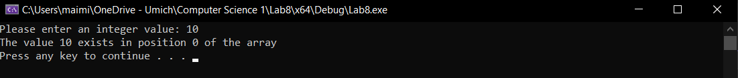

Test Case #2

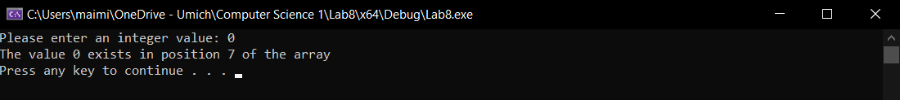

Test Case #3

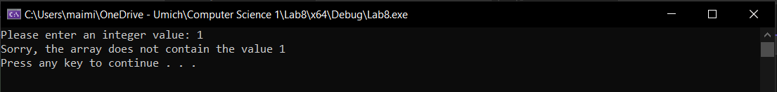

Test Case #4

